**Full Stack Development with MERN**

**Database Design and Development Report**

|  |  |
| --- | --- |
| Date | 11/07/2024 |
| Team ID | SWTID1720026558 |
| Project Name | Book a Doc |
| Maximum Marks |  |

**Project Title**: Book a Doc

**Date**: 15/07/2024

**Prepared by**: Snigdha, Aadya Nair, Naveen George Joseph, Mihir Rana

**Objective**

The objective of this report is to outline the database design and implementation details for the "Book a Doctor" project, including schema design and database management system (DBMS) integration.

**Technologies Used**

* **Database Management System (DBMS):** MongoDB

**Design the Database Schema**

The database schema is designed to accommodate the following entities and relationships:

### 1. Users

**Attributes:**

* _id
* name
* email
* password
* createdAt
* updatedAt

### 2. Doctors

**Attributes:**

* _id
* name
* specialty
* location
* createdAt
* updatedAt

**Implement the Database using MongoDB**

The MongoDB database is implemented with the following collections and structures:

**Database Name:** book_a_doctor

### 1. Collection: users

**Schema:**

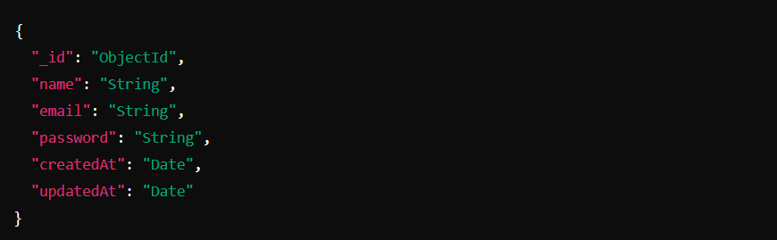

### 2. Collection: doctors

**Schema:**

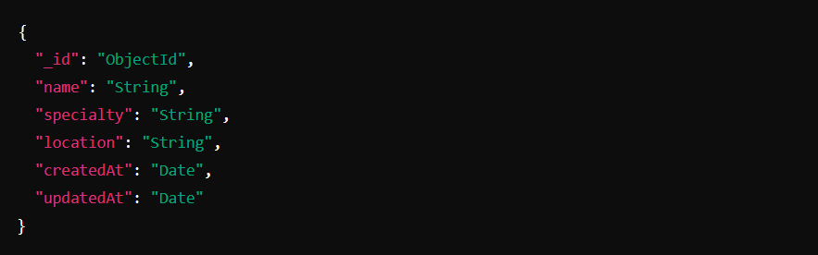

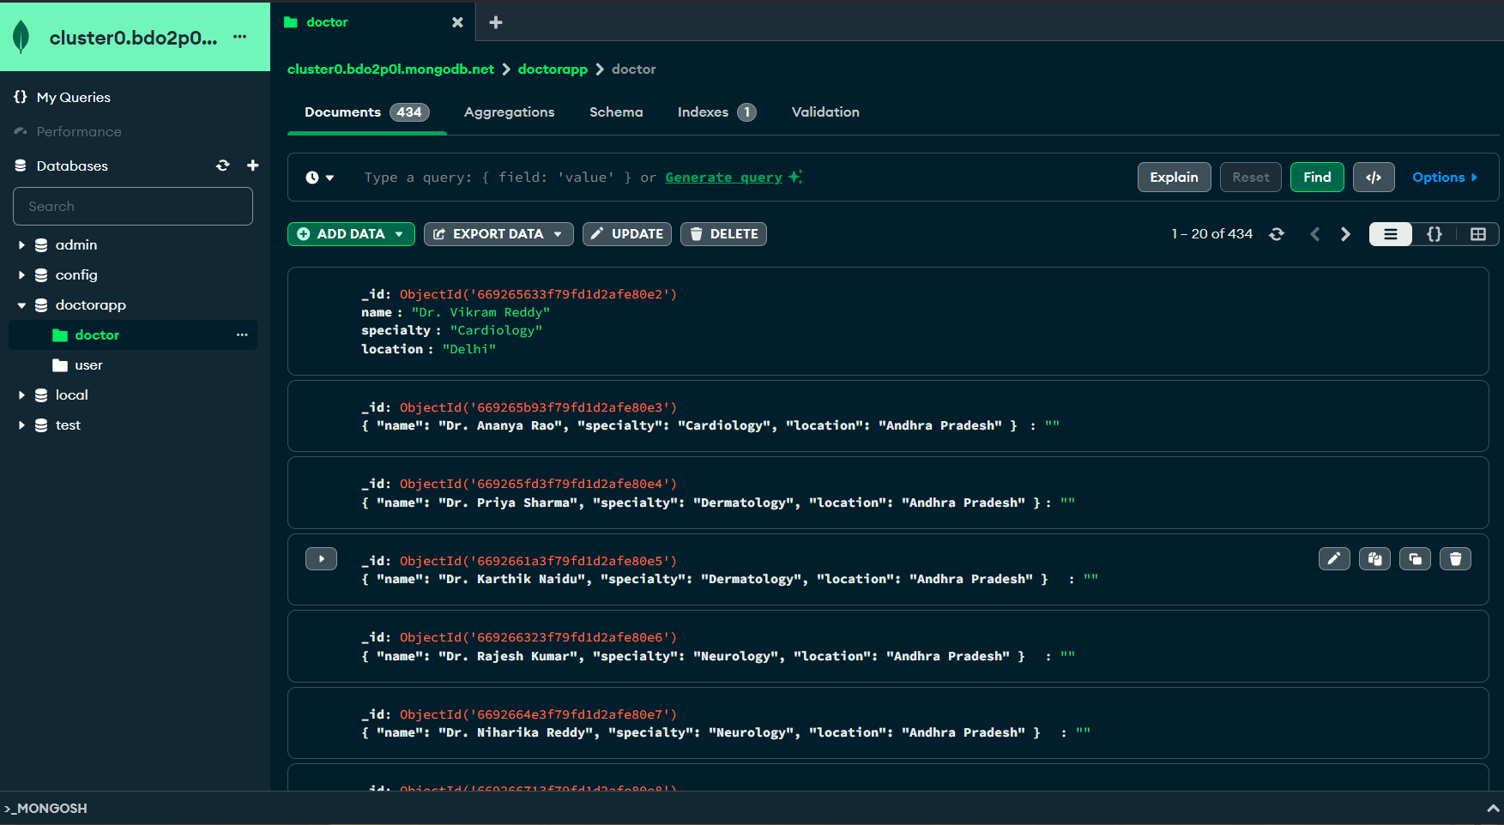

**Integration with Backend**

* Database connection: Integration of backend with data string using mongoose:

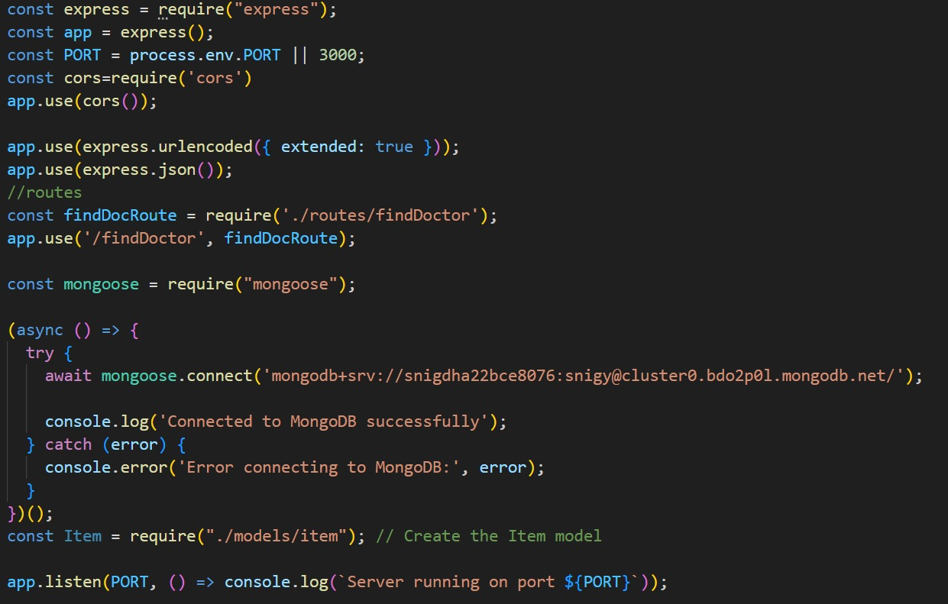

* Defining the schema for the doctor’s database:

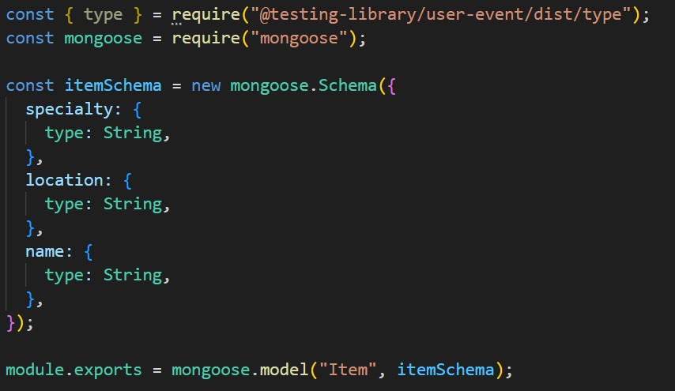

* API prepared for interacting with react:

